

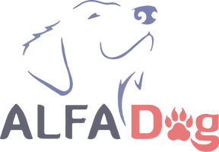







**Issued:**

Name: 

Reference:

Pay Period:

DUE DATE:





| Plan Diamond | - | - | $2320 |
| --- | --- | --- | --- |
| Dog School | - | 4x p/w | - |
| 1 on 1 Session  Online  Walks | -  -  - | 4x p/m  1x p/w  2x p/w | -  -  - |
| Group Session | - | - | - |
| Pet Hotel  Extra Dogs | -  - | -  -  Discount | -  -  20% |





Leading a better life

Issued: /23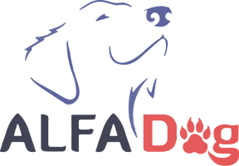

PAYMENT DETAILS

Account Name:Training ALFADOG

ABN:38 234 347 386

BSB:013017

ACC: 325973708

Ph: 0405539381

Email: info@alfadog.com.au



Important Information:

Payments must be completed before the next month or before the next session (if not on a membership plan). Invoices not finalized by this time will incur a $15 late fee, and dogs will not be able to participate in AlfaDog activities during the missed paid time.

We will send invoices two weeks before the end of the month for memberships.

Please send us a receipt confirmation once paid. We will then give you a call to book your sessions.

Please note that we require a minimum of 24hrs notice for cancellations. You will not be allowed to reschedule otherwise.

Refunds are not permissible.

Please notify us if any of your details have changed or if you are having processing issues.



Leading a better life